Audience profile

Likely users of the Ubuntu.com website include, but are not limited to:

* Developers, businesses and consumers interested in using an open source software environment or a Linux operating system.
* People looking for a free operating system.
* Consumers interested in smart phones or tablets with a Linux operating system.
* Consumers interested in web enabled TVs.
* People interested in public and enterprise level OpenStack[1] Cloud services.
* People interested in Linux web server software, specifically Ubuntu’s server software.
* Users interested in an operating systems customed for Chinese and Chinese keyboards.
* People or businesses looking to for training, support or consultancy with Linux, Ubuntu, or opensource software.
* Businesses intereseted in software for managing desktop or server deployment.
* People interested in Ubuntu merchandise.
* People with older computers or less powerful hardware who need an operating system that is easy on resources.
* Computer users who want the safest possible computers in terms of security.

People visiting this website might be more technically skilled or adventureous. They might have maverick pesonalities or like to explore alternatives.

They could be using any type of computer equipment or browser because Linux runs on many types of devices). It is possible that some users would use assitive technologies. The Orca screen reader, for example, is built-in to Ubuntu.

Figure 1 from <http://www.spyfu.com/Domain/-6410632579767590874> show the top five pages at Ubuntu.com. From this chart we can infer that visitors are mostly interested in the Cloud software, downloading an Ubuntu operating systems, the Ubuntu desktop operating system, or information on the Ubuntu phone. Quantcast has no data on this website.

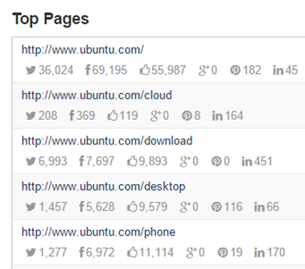

Figure 1. Top pages at Ubuntu.com (source: http://www.spyfu.com) .

1. Open source software for creating private and public clouds.